(Didn’t see the take a picture of the github issues until after we started the 3rd sprint in this Milestone, so I don’t have progressive pictures from each Sprint)

(Sprint Planning Documents Below)

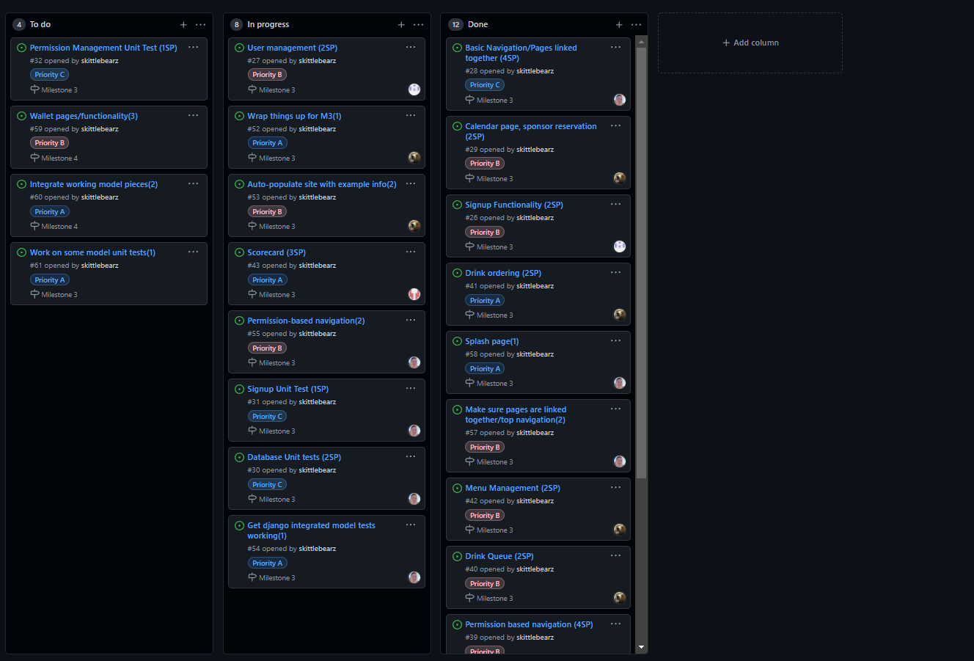

Sprint Planning

Sprint ending 10/18/21

Attendees

* Ben Ashton (Scrum Master)
* Erik Johnson
* Jonathan Scoresby
* Jordan Taylor

TimeLine:

Database models working

User creation

User management

Frontend layout, navigation, pages in place

Unit testing for built functionality

Goal -

Task Breakdown:

Frontend

Database

Account Management

Tickets to make

Database - 3

* Users
  + Wallet
  + Score card
* Drinks
* Calendar

Database Unit test - 2

Signup functionality, create user - 2

User management, manage permissions - 2

Basic navigation and pages created - 4

Unit testing -

* Signup Functionality - 1
* User manage - 1

Calendar page, sponsor reservation - 2

Sprint Planning

Sprint ending 11/01/21

Attendees

* Ben Ashton
* Erik Johnson (Scrum Master)
* Jonathan Scoresby
* Jordan Taylor

TimeLine:

* Get lots more functionality implemented
* Get frontend looking nice
* UI testing on completed pages

Task Breakdown:

User Management

Finish Drink Queue

Splash page/frontend bringup

Scorecard

Tickets to make

User management (2)

Drinks

* Drink Ordering (2)
* Drink Queue(2)
* Drink Management(2)

Frontend Design

* Splash Page(2)
* Frontend bringup(2)

Other functionality to start implementing

* Scorecard(3)
* Wallet(3)

Tests

* Unit tests(1)
* Unit tests(1)

Sprint Planning

Sprint ending 11/16/21

Attendees

* Ben Ashton
* Erik Johnson
* Jonathan Scoresby
* Jordan Taylor (Scrum Master)

TimeLine:

* Get integration of different pages/functionality
* Permission based navigation
* Wrap things up for Milestone 3

Task Breakdown:

Integration

Get some unit test going

Auto-populate site with info

Testing

Tickets to make

Integration

* Make sure pages are linked together/accessible(1)
* Get models working

Testing

* Get some unit test going
* Manually test UI (edge cases)
* Create django built in tests

Auto-populate site with info

* Create django migration population script(1)
* Add info filler info for the all models(1)

Wrap things up for M3(1)

* Update/test build instructions
* compile/make sure everything is in place
* Test website before submitting